Computer Communications and Networks (COMN)
2016/17, Semester 2

Assignment Part 2 Results Sheet
Forename and Surname: | Jianmeng Yu
Matriculation Number: | s1413557

Question 1 – Experimentation with Go-Back-N:
 | Throughput (Kilobytes per second)
Window Size | Delay = 5ms | Delay = 25ms | Delay = 100ms
1 | 50.95 | 16.76 | 4.95
2 | 99.40 | 33.28 | 9.59
4 | 205.35 | 65.70 | 19.01
8 | 393.59 | 130.09 | 38.17
16 | 383.75 | 259.18 | 75.48
32 | 441.70 | 417.54 | 125.66
64 | 465.34 | 447.55 | 133.73
128 | 538.38 | 488.37 | 139.09
256 | 527.38 | 460.46 | 150.80
Create a graph as shown below using the results from the above table: 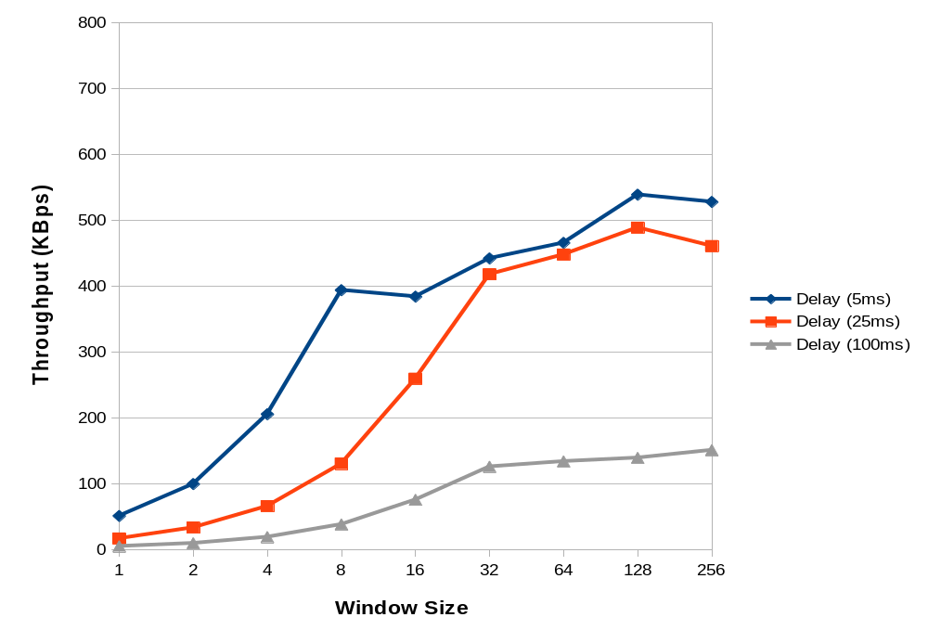
Question 2 – Discuss your results from Question 1.

The throughtput of data doubles with the window size for small window sizes, as the Sender utilize the wait time to send furthur packets. When the window size keeps increase the sequence number may not catch up with the window, so it basically relys on the timeout to resend everything, resulting in the limit in speed, hence limiting the throughput around 400-500KBps. For the 100ms case, the limit is much lower (around 100-200KBps), because sometimes the ACK package is lost, resulting in waiting for all the packages in the window to be resent, this and the long timeout for high delay, lowering the speed.

Question 3 – Experimentation with Selective Repeat

 | Throughput (Kilobytes per second)
Window Size | Delay = 25ms
1 | 9.85
2 | 19.64
4 | 37.43
8 | 72.59
16 | 143.48
32 | 258.04

Question 4 - Compare the throughput obtained when using “Selective Repeat” with the corresponding results you got from the “Go Back N” experiment and explain the reasons behind any differences.

Question 5 – Experimentation with iperf

 | Throughput (Kilobytes per second)
Window Size (KB) | Delay = 25ms
1
2
4
8
16
32

Question 6 - Compare the throughput obtained when using “Selective Repeat” and “Go Back N” with the corresponding results you got from the iperf experiment and explain the reasons behind any differences.

